This is your prep email for the 10-HOUR CHATTANOOGA EPIC ADVENTURE RACE. If you are NOT in this event and receive this email, please let us know as soon as possible. Also, please forward this email to your teammates.
For the latest race updates and discussion, Like or Follow the Chattanooga Epic Adventure Race Facebook page.
Keep an eye on the weather and plan accordingly. It is spring, so rain is always a possibility.
We look forward to seeing everyone in Chattanooga, Tennessee. Please review the schedule below. All team members must be present for you to check-in, unless special arrangements have been made with us before!
CHECK-IN: Ross’ Landing, Chattanooga, TN
201 Riverfront Pkwy, Chattanooga, TN 37402
https://maps.app.goo.gl/3kkrNJpwses7t9j1A
Look for the tent and the Warrior Adventure Racing flags
PARKING: Parking is only allowed in the parking area across the street from check-in as shown below. YOU WILL RECEIVE A TICKET if you do not IMMEDIATELY get a parking pass from the check-in tent. As soon as you park, go to check-in and ask them for a parking pass. This needs to be placed inside your car on the front windshield. This will allow you to park there for the duration of the race. Do this ASAP.
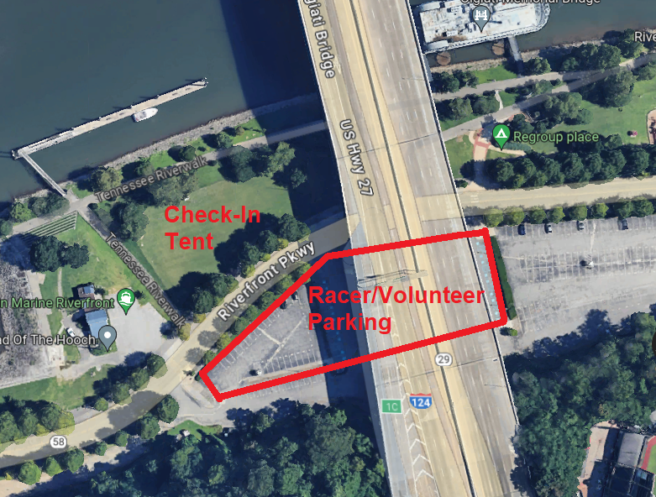
Race Morning Schedule (Saturday, April 6)
6:00am - Check-In Starts
7:00am - Pre-Race Meeting
7:30am - Load Buses
8:00am - Race Start At Undisclosed Location

Make sure you review the updated gear list: https://www.warriorraces.com/ar-gear-list
Your team will be given a GPS tracker by Adventure Enablers and a link will be shared with you the week before the race in which your friends and families can watch your team as they travel across the Chattanooga area.
Each racer must wear the supplied race bibs for the entirety of the race. Bibs must be worn on top of all clothing. PFDs and packs can be worn over the bibs.
Water and Snacks are available at all TA’s.
You will NOT be required to wear helmets during the paddle.
Attached is the race schematic that will allow you to plan out your equipment choices.
Race instructions will be provided to teams at check-in; however, maps will not be distributed until the race starts.
GPS Devices ARE allowed in this race. However, the ability to read a map is essential. A compass is required gear. DO NOT RELY SOLELY ON YOUR WATCH NOR OTHER GPS DEVICE FOR NAVIGATION!
Your bikes and bike gear will be loaded on trucks for transport to TA2. Attach helmets and shoes to your bikes before loading. Make sure red blinkies are attached to the rear of the bicycle before loading.
NOTE: Chattanooga is in Eastern time. We are very near the Central Time Zone border and part of the course will be in the Central Time Zone. However, all times in the schedule above, as well as cut-off times during the race will be in Eastern Time, so set your watches accordingly.

