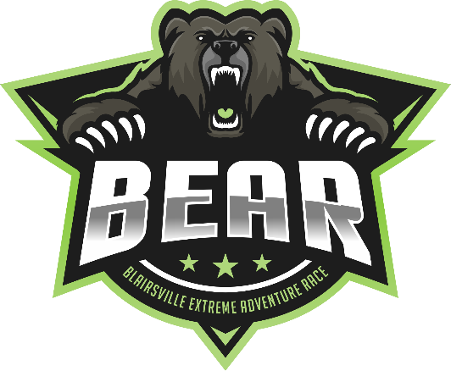
BEAR Adventure Race 8 Hour 2020
September 26th, 2020

We are allowing 10 hours to complete this year’s race. Finish by 7pm.
Thanks: Town of Blairsville and the National Forest Service for supporting the BEAR 2020.
Safety is your responsibility.
MAIN CONTACTS
- Emergency: 911
- Race Commander: Tracey Brower (706) 286-4008
- Race Director: Jeff Leininger: (904) 477-5067
- Planning and Logistics: Bruce Meier (904) 705-8758

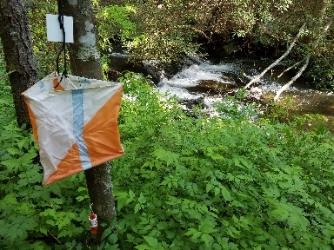

ACCESS FOR EMERGENCY VEHICLES
- Duncan Ridge Road, Suches, GA 30572
- Copper Creek Campground, Suches, GA 30572

EMS, FIRE, HOSPITALS and SHERIFF

- Local EMS will be notified that this event will take place and the nearest service has been identified as:
- Union County Emergency Management (706) 439-6091, 507 Shoe Factory Rd, Blairsville, GA 30512
Local Hospitals have been identified as:
- Union General Hospital: (706) 745-2111 35 Hospital Rd, Blairsville, GA 30512
Local Sheriff / Police departments have been identified as:
  - Blairsville Police. Officer on Duty: (706) 835-1692 62 Blue Ridge St, Blairsville, GA 30512
  - Union County Sheriff's Office (706) 439-6066 378 Beasley St, Blairsville, GA 30512
  - Forest Service Officer: Mike Tipton (706) 633-6419 2042 Hwy 515 West, Blairsville, GA 30512

Mandatory Gear must be carried entire race. Gear check during race. Penalty applies if teams are missing required gear. Complete list on website or at check-in table.

- Team separation may not exceed 30 meters. Some CPs will require all team members to visit.
- Life vest must be worn at all times while boating.
- Bike helmet must be worn at all times while biking. Red blinking rear light at all times day or night.
Penalties for any above rule violation: 1 point per violation. List of complete rules on website and at check-in.
All team members must check in to exchange punch card. The 30-meter rule applies in TAs as well.

Teams will have 10 hours to complete course. Penalties begin after 10 hours.
-.01 second after 10 hours = 1 point
-15.01 minutes after 10 hours = 2 points
-30.01 minutes after 10 hours = 3 points
-45.01 minutes after 10 hours = OT (Over Time)

This race is a Modified Rogaine format.
Teams may collect any Control Points (CPs) in any order per each section. When visiting each TA (Transition Area), teams will be forced to change disciplines and retrieve CPs for that section using the discipline lay out in the description below. Teams will trade in Punch Cards for new Punch Cards at some TAs, so always check-in with race staff at each TA. Keep an eye on the clock, you don’t want to be late to the Finish. If your team losses the Punch Card, please just punch the side of the map and we will work it out at the end of that section. Penalty (1 CP)

START TREK (Punch Card #1)

On Foot (one teammate only) visit below control point and then return to Start Location to get on bikes.
CP 1 – Campsite along trail.

BIKE (Punch Card #1)

On Bike teams travel to TA #1 collecting CP 2 through CP 5 along the way.
CP 2 – Gate
CP 3 – Jeep Trail
CP 4 – Spur between road and trail.
CP 5 – Creek intersection
Teams arrive at TA #1 and check-in with staff on placement of bikes. Turn in Punch Card #1 and receive Punch Card #2 to start the trek section.
TREK (Punch Card #2)

On foot visit the below control points CP 6 through CP 13 in any order. Teams must leave TA #1 by 4:00pm!
CP 6 – Spur NW of trail
CP 7 – Creek
CP 8 – Creek intersection (same as CP 5)
CP 9 – Hilltop
CP 10 – 15 meters North of Trail Intersection
CP 11 – Hilltop
CP 12 – Hilltop
CP 13 – Reentrant
After this section Teams return to TA #1 and turn in Punch Card #2 to receive Punch Card #3.

BIKE (Punch Card #3)

Teams bike to retrieve CP 14 through CP 17 on the way to TA #2/Finish. Before you leave, please make sure your red blinking lights are on and working. Single file riding on public roads. No riding bikes on foot trails in Meeks Park.
CP 14 – Spur at Mulky Gap
CP 15 – Creek
CP 16 – Church
CP 17 – Cemetery
Teams arrive at TA #2/Finish and check-in with staff on placement of bikes. Turn in Punch Card #3 and receive Punch Card #4 then on foot to the Canoe Launch. If you have your own paddle gear, take it with you here.

PADDLE (Punch Card #4)

Paddle to retrieve CP 18 through CP 22 in any order on the way back to the Canoe Launch: CP 22 can only be received after your team has transported the boats back to the Penske Trucks.
CP 18 – Under Bridge
CP 19 – Creek
CP 20 – Creek
CP 21 – Cove
CP 22 – Teams carry boats from the water to the Penske Trucks.
After the paddle proceed on foot to the Finish and turn in Punch Card #4

Congratulations on completing the 2020 Blairsville Xtreme Adventure Race.

