This is your prep email for the 30-HOUR CHATTANOOGA EPIC ADVENTURE RACE. If you are NOT in this event and receive this email, please let us know as soon as possible. Also, please forward this email to your teammates.
For the latest race updates and discussion, Like or Follow the Chattanooga Epic Adventure Race Facebook page.
Please note that Chattanooga can have pretty cold nights in early April, so keep an eye on the weather and plan accordingly. It is spring, so rain is always a possibility. Plan for wet feet at the least as you will be crossing many waterways during the race.
We look forward to seeing everyone in Chattanooga, Tennessee. Please review the schedule below. All team members must be present for you to check-in, unless special arrangements have been made with us before!
CHECK-IN: Ross’ Landing, Chattanooga, TN
201 Riverfront Pkwy, Chattanooga, TN 37402.
https://maps.app.goo.gl/3kkrNJpwses7t9j1A
Look for the tent and the Warrior Adventure Racing flags
PARKING: Parking is only allowed in the parking area across the street from check-in as shown below. YOU WILL RECEIVE A TICKET if you do not IMMEDIATELY get a parking pass from the check-in tent. As soon as you park, go to check-in and ask them for a parking pass. This needs to be placed inside your car on the front windshield. This will allow you to park there for the duration of the race. Do this ASAP.
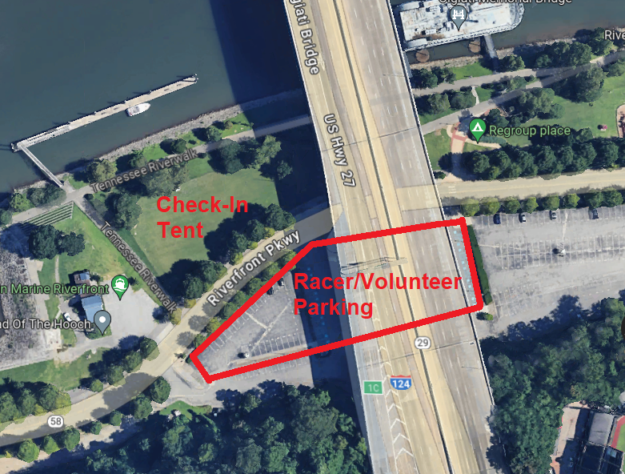
Race Morning Schedule (Friday, April 5)
9:00am - Check-In Starts
10:30am - Paddle Bags Must Be Loaded On Truck
10:30am - Pre-Race Meeting
11:00am - Load Buses
12:00pm - Race Start At Undisclosed Location

Please attach your large race numbers to your bikes. We provide zip ties and pins for this purpose. Printed labels go on bins (one on each side). All bins must be from Lowes and have a 40lb weight limit with no exceptions. If you show up with any other bins, you will be required to change bins before loading them on the trucks. (https://www.lowes.com/pd/COMMANDER-27-Gallon) We will have them at the check-in if needed for $20. Bikes and bins will be loaded onto trucks for transport to the second TA (see attached schematic).
Make sure you review the updated gear list: https://www.warriorraces.com/ar-gear-list
Your team will be given a GPS tracker by Adventure Enablers and a link will be shared with you the week before the race in which your friends and families can watch your team as they travel across the Chattanooga area.
Water and Snacks are available at all TA’s. Gatorade and sodas will be available in our coolers, so don't pack them in your bins.
Please ensure that each racer has a red blinking light on the rear of your bike and the bike helmet. Both are mandatory!
Each racer must wear the supplied race bibs for the entirety of the race. Bibs must be worn on top of all clothing. PFDs and packs can be worn over the bibs.
Maps and instructions will be provided to teams at check-in.
You will NOT be required to wear helmets during the paddle.
Attached is the race schematic that will allow you to plan out your equipment and how to pack your bins.
NOTE: Chattanooga is in Eastern time. We are very near the Central Time Zone border and part of the course will be in the Central Time Zone. However, all times in the schedule above, as well as cut-off times during the race will be in Eastern Time, so set your watches accordingly.

